MINI ATM SIMULATOR

19IT251 OBJECT ORIENTED PROGRAMMING USING C++ LAB

MINI PROJECT REPORT

SUBMITTED BY ,

N.A.KISHORE [9517202206024]



2022 - 2023
CERTIFICATE

This is to Certify that it is the bonafide work done by N.A.KISHORE for their Mini Project on Title of the project in the 19IT251 – Object Oriented Programming using c++ Laboratory at Mepco Schlenk Engineering College, Sivakasi during the year 2023-2024.

.………………… …………………………

Staff in charge Head of the Department
ACKNOWLEDGEMENT

We have taken efforts in this project. However, it would not have been possible without the kind support and help of many individuals and our reputed institution Mepco Schlenk Engineering College, Sivakasi. We would like to extend our sincere thanks to our Principal Dr. S. Arivazhagan ME., PhD.

We would like to express my special gratitude and thanks to Dr.T.Revathi ME., PhD. Senior Professor & Head of the Department for giving us such a wonderful experience.

We are highly indebted to Dr.G.Yogarajan BE,.ME,.PhD Associate professor/IT, Dr.A.S.Karthik Kannan B.Tech, Mtech, PhD, PDF AP(SI.G.)/IT for their guidance and constant supervision as well as for providing necessary information regarding the project & also for their support in completing the project.

We would like to express our gratitude towards other teaching and non teaching staff members of IT Department for their kind co-operation and encouragement which help us in all means to complete this project successfully.
ABSTRACT

Our mini project is about building a simple yet functional Automated Teller Machine (ATM) system using C++. The objective is to create an interactive and user-friendly interface that allows account holders to perform basic banking operations, including withdrawals, deposits, balance inquiries, and money transfers.

The program begins by offering users the option to create a new account by entering their personal information, such as name, account type (domestic or international), phone number, password, and initial balance. The account details are stored in a file called "accounts.txt" for future reference.

Once an account is created or if the user already has an account, they can insert their card, enter their PIN, and access their account options. The system provides a menu for domestic accounts, offering the choice between savings and current accounts, while international accounts are not available in this version.

The ATM allows users to perform various transactions securely. They can withdraw funds, deposit money, check their account balance, and even transfer money to other account holders within the system. Additionally, the system generates transaction receipts with relevant details, ensuring transparency for users.

Furthermore, we have added a thoughtful feature to prompt users about receiving a detailed receipt after a money transfer. By giving them the option to choose (Y/N), we ensure their preferences are met and create a more personalized user experience.

Overall, our ATM mini project serves as an excellent demonstration of a fundamental banking system with the ability to create and manage accounts, perform transactions, and produce detailed receipts, providing users with a realistic ATM simulation.
TABLE OF CONTENTS

CONTENT | PGNO
1.Introduction | 6
1.1Purpose | 7
1.2 Definitions, Acronyms and Abbreviations | 8
1.3 Role of OOP | 9
1.4 Overview | 10
1.5 Reference | 10
2.Implementation/Coding | 11
3..Screen Shots | 18
4.Conclusion | 25

1.INTRODUCTION

This code presents a simple yet functional Automated Teller Machine (ATM) system implemented in C++. The primary goal of this mini project is to create an interactive and user-friendly interface, enabling account holders to conduct basic banking operations, including withdrawals, deposits, balance inquiries, and money transfers.

The program commences by providing users with the option to create a new account by entering their personal information, such as name, account type (domestic or international), phone number, password, and initial balance. The account details are stored in a file named "accounts.txt" to facilitate future reference and access.

Upon successful account creation or if the user already possesses an account, they can insert their card, input their confidential PIN, and effortlessly access their account options. The system promptly offers a menu for domestic accounts, presenting choices between savings and current accounts, while international accounts are presently unavailable.

The ATM system facilitates secure and seamless transactions for users, enabling them to withdraw funds, deposit money, check their account balance, and even transfer money to other account holders within the system. Notably, the system generates comprehensive transaction receipts containing relevant details to ensure transparency and proper record-keeping for users.

Additionally, this code introduces an insightful feature where users are prompted to indicate whether they desire a detailed receipt after conducting a money transfer. By offering users the option to choose (Y/N), the system ensures personalized user experiences and enhances overall satisfaction.

In conclusion, this ATM mini project serves as an excellent demonstration of fundamental banking system, encompassing essential functionalities like account management, secure transactions, and detailed receipt generation. The code creates a realistic ATM simulation, providing users with a convenient and comprehensive virtual banking experience.
  - PURPOSE

Our mini-project revolves around the development of an interactive and efficient Automated Teller Machine (ATM) system using C++. The primary objective of this endeavor is to simulate a real-world ATM experience, providing users with the convenience of performing various banking tasks from the comfort of their homes or any location equipped with an ATM machine.

One of the key functionalities of our code is the ability to facilitate the creation of new accounts. Users can input their essential personal details, such as their name, account type (domestic or international), phone number, password, and initial balance, to initiate the account creation process.

To ensure secure access to their accounts, the code implements a personalized login mechanism. Account holders can insert their cards and enter their confidential PINs, which act as their unique access keys.

Furthermore, the system offers a user-friendly menu specifically for domestic account holders, empowering them to efficiently manage their accounts. They can check their account balance, make withdrawals, deposits, and execute money transfers within their accounts.

A notable feature of our code is the generation of detailed transaction receipts. These receipts provide users with comprehensive information about their transactions, including transaction type, amount, current balance, and transaction date/time. Additionally, we have incorporated an innovative option for users to decide whether they want a detailed receipt after performing money transfers, thereby enhancing their overall banking experience.

In conclusion, our mini-project aims to create a sophisticated, secure, and user-friendly ATM system that closely replicates real-world banking
  - DEFINTION:

ATM (Automated Teller Machine) - An electronic banking device that enables customers to conduct various financial transactions, such as withdrawals, deposits, fund transfers, and balance inquiries, without visiting a physical bank branch.

ACRONYMS:

Users can create or access existing accounts with options for Savings or Current Accounts. It allows them to withdraw, deposit, check balances, and transfer money. The system ensures sufficient balance for withdrawals and provides transaction receipts. Acronyms used include ATM, PIN, Rs (Indian Rupees), and Y/N (Yes/No).

ABBREVATIONS:

ATM: Automated Teller Machine
PIN: Personal Identification Number
Rs: Indian Rupees
Y/N: Yes/No
std: Standard (refers to the standard namespace in C++)
cin: Console Input
cout: Console Output
EOF: End of File
ios: Input/Output Stream
getline: Get Line (used to read a line of text from input)
ofstream: Output File Stream
ifstream: Input File Stream
endl: End Line (used to insert a new line in the output)
_DATE_: Compilation Date (preprocessor macro to get the current date of compilation)
_TIME_: Compilation Time (preprocessor macro to get the current time of compilation)
  - ROLE OF OOP:

The role of Object-Oriented Programming (OOP) is to provide a programming paradigm that emphasizes the organization and modeling of software as a collection of objects that interact with each other. OOP is designed to enhance code reusability, maintainability, and scalability, making it easier to manage complex software projects.

The key roles of OOP include:

1. Encapsulation: OOP allows data and the methods that operate on that data to be encapsulated within objects. This helps in controlling access to data and ensures that the internal implementation details are hidden, promoting information hiding and data protection.

2. Inheritance: Inheritance enables the creation of new classes (subclasses) based on existing classes (superclasses). Subclasses inherit the attributes and behaviors of their parent classes, allowing code reuse and the creation of a hierarchical structure.

3. Polymorphism: Polymorphism allows objects to be treated as instances of their parent class, enabling different objects to be used interchangeably. It facilitates code flexibility and extensibility, as well as the ability to handle objects in a generic way.

4. Abstraction: Abstraction allows the creation of abstract classes and interfaces that define the structure and behavior of objects without specifying their implementation details. This simplifies complex systems by focusing on essential features.

5. Modularity: OOP encourages the development of modular, self-contained units (classes), which can be easily integrated into larger systems. This promotes code organization and makes it easier to understand, modify, and maintain the codebase.

Overall, OOP provides a powerful framework for designing software solutions, allowing developers to model real-world entities effectively, leading to efficient, flexible, and maintainable code.

  - OVERVIEW:

The program is a mini ATM simulator based on Object-Oriented Programming (OOP) principles. It allows users to perform various banking operations, such as creating new accounts, checking balances, making withdrawals, deposits, and transferring money between accounts.

The program starts with the option to create a new account or proceed with an existing one. Users can input their account holder's name, account type, phone number, password, and initial balance to create a new account, which is then stored in a file.

For existing account holders, they can insert their card and enter their PIN to access their accounts. The system supports multiple account types, such as domestic savings accounts, with options for deposits, withdrawals, balance inquiries, and transferring money between accounts.

The code is organized using OOP principles, with the creation of an "Account" class that represents each individual account. The class contains methods for various banking operations, encapsulating data and functionality related to an account. Additionally, the program demonstrates inheritance, as specific account types like "Savings Account" are derived from the main "Account" class.

Overall, this mini-project showcases how OOP concepts can be utilized to build a user-friendly and functional ATM simulation, providing users with a virtual banking experience.

  - REFERENCE:
We refered our class notes and ANSI C++ book and internet.

2. IPLEMENTATION /CODING

#include <iostream>
#include <string>
#include <ctime>
#include <fstream>

using namespace std;

int createNewAccount() {
string accountHolder, TYPE, password;
double balance;
long int Phone;

cout << "Enter account holder's name: ";
cin.ignore();
getline(cin, accountHolder);

cout << "Enter account TYPE: ";
cin >> TYPE;

cout << "Enter account holder's Phone number: ";
cin >> Phone;

cout << "Enter password: ";
cin >> password;

cout << "Enter initial balance: $";
cin >> balance;

ofstream outFile("accounts.txt", ios::out);
if (outFile.is_open()) {
outFile << "Account holder's name: " << accountHolder << endl
<< "\nAccount TYPE: " << TYPE << endl
<< "\nAccount holder's Phone number: " << Phone << endl
<< "\nInitial balance: $" << balance << endl
<< "\nPassword: " << password << "@";
outFile.close();
cout << "\nAccount created and stored in file successfully.\n";
} else {
cout << "\nError: Unable to open file.\n";
}

ifstream inFile("accounts.txt", ios::in);
if (!inFile.is_open()) cout << "Error: Unable to open the file.";

return 0;
}

cout << "-----Data present in the file -----\n";
string line;
while (getline(inFile, line) && line != "@") {
cout << line << endl;
}

inFile.close();
return 0;
}

class Account {
public:
string accountHolder;
double balance;
string accountType;
int accountID;

Account(string a, int c, double b) {
accountHolder = a;
balance = b;
accountID = c;
}

void display(Account& b1, Account& b2, Account& b3) {
cout << "\n********************************************\n";
cout << "* *\n";
cout << " * Welcome to the ATM, " << accountHolder << " *\n";
cout << "* *\n";
cout << "********************************************\n\n";

cout << "Welcome - " << accountHolder << "!" << endl;
cout << "\nPress Enter to proceed\n";
cin.ignore();
cin.get();
cout << "\n----- ACCOUNT TYPE MENU -----" << endl << endl;
cout << "1. Domestic Account";
cout << "\t2. International Account(Not available)" << endl;
cout << "\nEnter your choice: ";
int accountChoice;

cin >> accountChoice;
switch (accountChoice) {
case 1:
domesticAccount(b1, b2, b3);
break;
case 2:
cout << "\nInternational account not available.";
cout << "\nPress Tab to take your card." << endl;
break;
default:
cout << "Invalid choice. Please try again." << endl;
break;
}
}

void domesticAccount(Account& b1, Account& b2, Account& b3) {
cout << "\nYou have selected Domestic Account." << endl;
accountType = "Savings Account";
int accountChoice;

cout << "\n1. Savings Account";
cout << "\t2. Current Account (Not Available)" << endl;
cout << "\nEnter your choice: ";
cin >> accountChoice;
switch (accountChoice) {
case 1:
cout << "\nYou have selected Savings Account." << endl;
savingsAccount(b1, b2, b3);
break;
default:
cout << "Invalid choice. Please try again." << endl;
break;
}
}

void savingsAccount(Account& b1, Account& b2, Account& b3) {
while (true) {
int choice;
cout << "*********** " << accountHolder << "-" << accountType << " ***********" << endl;
cout << "--------------------------------------------\n";
cout << "| ATM MENU |\n";
cout << "--------------------------------------------\n";
cout << "| 1. Withdraw |\n";
cout << "| 2. Deposit |\n";

cout << "| 3. Balance Enquiry |\n";

cout << "| 4. Transfer Money |\n";
cout << "| 5. Exit |\n";
cout << "--------------------------------------------\n";
cout << "Enter your choice: ";
cin >> choice;
switch (choice) {
case 1:
long double withdrawAmount;
cout << "Enter withdrawal amount: $";
cin >> withdrawAmount;
withdraw(withdrawAmount);
break;
case 2:
long double depositAmount;
cout << "Enter deposit amount: $";
cin >> depositAmount;
deposit(depositAmount);
break;
case 3:
cout << "Your current balance is $" << balance << endl;
cout << "Press Enter to proceed\n";
cin.ignore();
cin.get();
break;
case 4:
transferMoney(b1, b2, b3);

break;
case 5:

cout << "Thanks and have a great day!" << endl;
cout << "Press Tab to take your card." << endl;
return;
break;
default:
cout << "Invalid choice. Please try again." << endl;
break;
}
}
}

bool checkWithdraw(double amount) {
const double minimumBalance = 100.0;
if (balance - amount >= minimumBalance) {
balance -= amount;
return true;
}
return false;
}

void deposit(long double dp) {
balance += dp;
cout << "Deposit successful." << endl;
printReceipt("\nAmount deposited", dp);
}

void withdraw(double wd) {
if (checkWithdraw(wd)) {
cout << "Withdrawal successful." << endl;
printReceipt("\nAmount withdrawn", wd);
} else {
cout << "Insufficient funds or violating minimum balance requirement." << endl;
}
}

void transferMoney(Account& b1, Account& b2, Account& b3) {
double transferAmount;
cout << "Enter transfer amount: $";
cin >> transferAmount;

int recipientAccountNumber;
cout << "1. Kishore " << endl;
cout << "2. Hari " << endl;
cout << "3. Dhanis " << endl;
cout << "Enter recipient account number: ";
cin >> recipientAccountNumber;

switch (recipientAccountNumber) {
case 1:

transfer(transferAmount, b1);

break;
case 2:
transfer(transferAmount, b2);

break;
case 3:

transfer(transferAmount, b3);
break;
default:
cout << "Invalid recipient account number." << endl;
break;
}
}

void transfer(double amount, Account& r) {
if (amount <= balance) {
balance -= amount;
r.balance = r.balance + amount;
cout << "Transfer successful." ;
cout << "You transferred Rs." << amount << " From " << accountHolder << " to " << r.accountHolder ;
cout << r.accountHolder << " Balance for - " << r.balance;

char receiptChoice;
cout << "\nDo you want a detailed receipt? (Y/N): ";
cin >> receiptChoice;
if (receiptChoice == 'Y' || receiptChoice == 'y') {
printReceipt("Amount transferred", amount);
} else {
cout << "\nThank you for your transaction." ;
cout << "Press Enter to proceed\n";
cin.ignore();
cin.get();
}
} else {
cout << "Transfer failed. Insufficient funds." << endl;
}
}

void printReceipt(const string& transactionType, double amount) {
cout << "\n*******************************************\n";
cout << "\tATM TRANSACTION RECEIPT\n";
cout << " \n*******************************************\n";
cout << "\nAccount Holder: " << accountHolder << endl;
cout << "\nAccount Type: " << accountType << endl;
cout << transactionType << ": Rs." << amount << endl;
cout << "\nCurrent Balance: Rs." << balance << endl;
cout << "\nTransaction Date & Time: " << __DATE__ << " " << __TIME__ << endl;
cout << "\n*********************************************\n";

cout << "End of Transaction\n";
cout << "Press Enter to proceed\n";
cin.ignore();
cin.get();
}
};

int main() {

Account a2("Hari", 102, 2000.0);
Account a3("Dhanis", 103, 3000.0);
string insertedCard;
string enteredPin;
int createAccountChoice;

cout << "\nDo you want to create a new account?\n";
cout << "1. Yes (create New Account)\n";
cout << "2. No (Already Available)\n";
cout << "Enter your choice: ";
cin >> createAccountChoice;

if (createAccountChoice == 1) {
createNewAccount();
return 0;
}

cout << "Press Enter to insert your card." << endl;
getline(cin, insertedCard);

cout << "Enter your PIN: ";
cin >> enteredPin;

if (enteredPin == "7373") {
a1.display(a1, a2, a3);
} else if (enteredPin == "1111") {
a2.display(a1, a2, a3);
} else if (enteredPin == "3333") {
a3.display(a1, a2, a3);
} else {
cout << "PIN is wrong!!" << endl << "************** Reload It **************";
}

return 0;
}
3.SCREENSHOTS

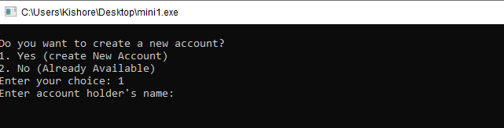
Figure 1

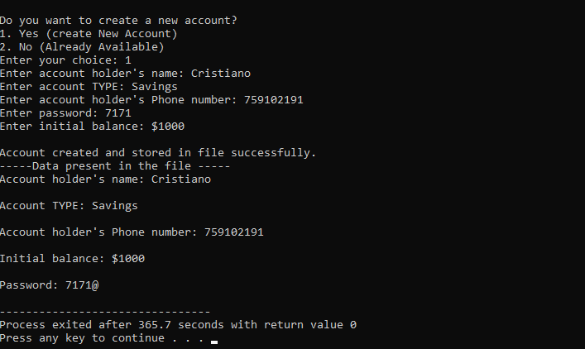
Figure 2

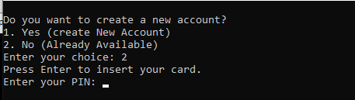
Figure 3

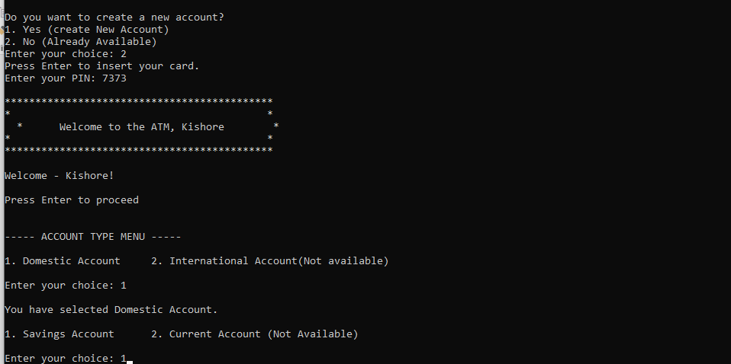
Figure 4

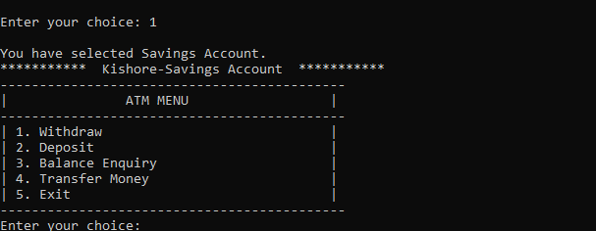
Figure 5

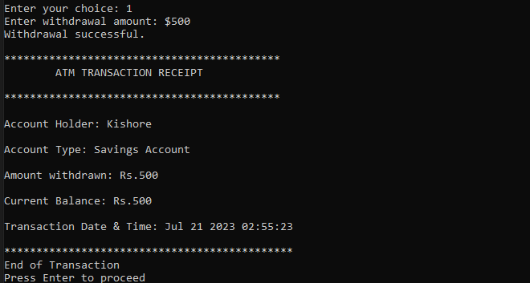
Figure 6

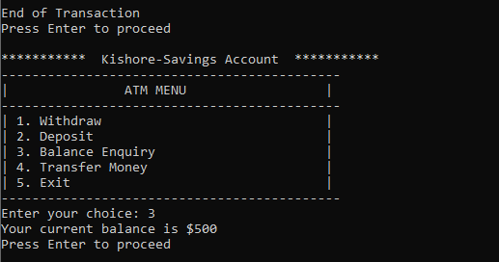
Figure 7

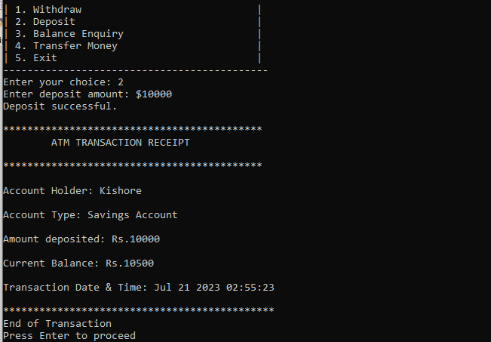
Figure 8

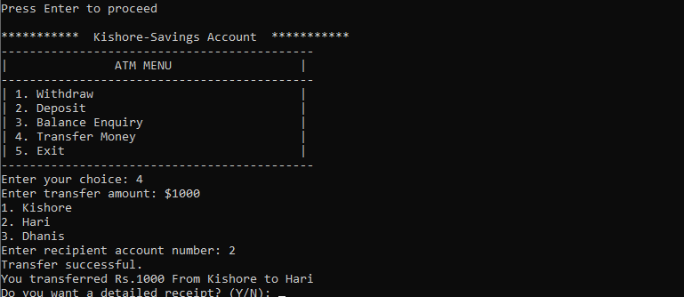
Figure 9

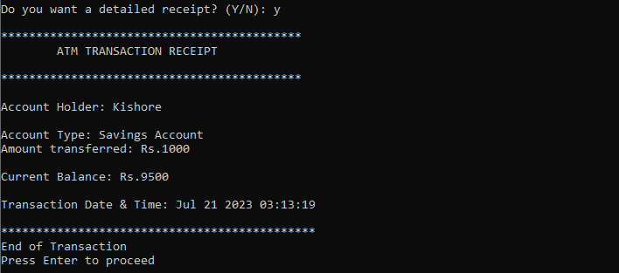
Figure 10

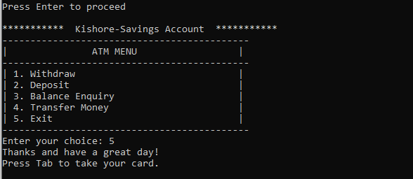
Figure 11

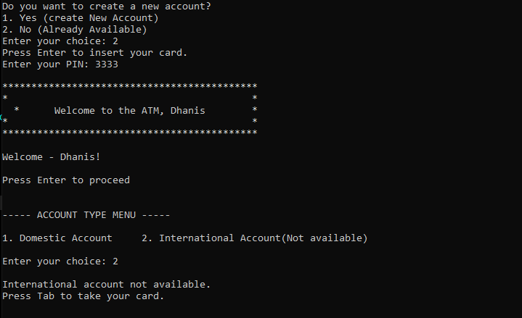
Figure 12

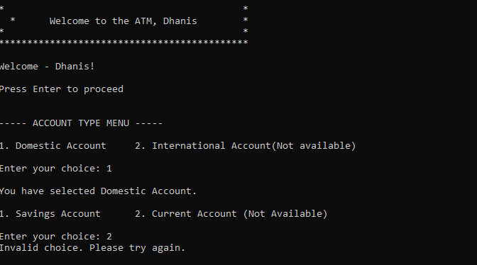
Figure 13

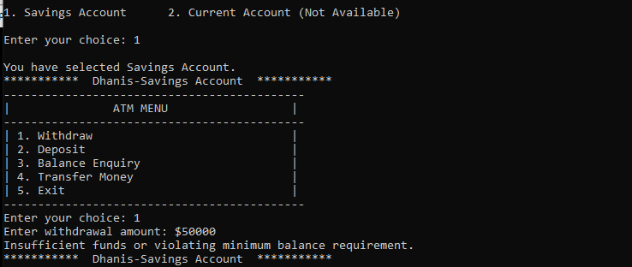
Figure 14

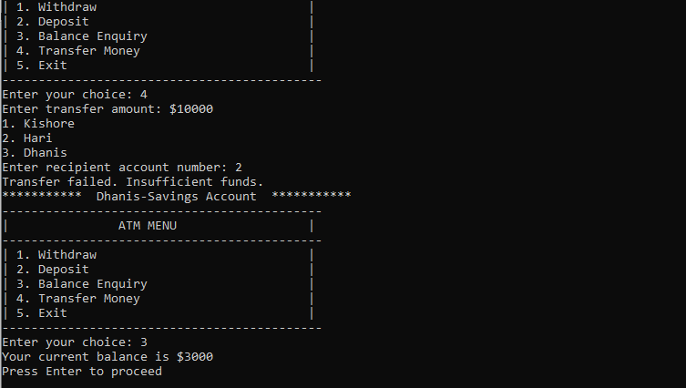
Figure 15

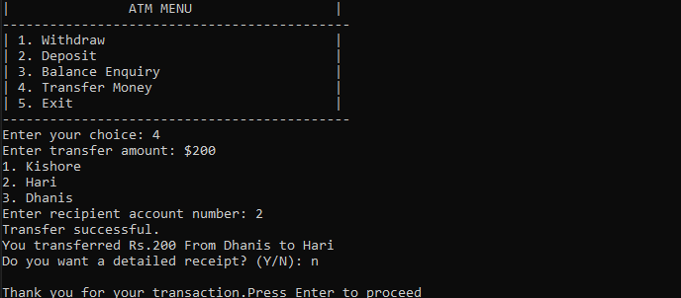
Figure 16

4.CONCLUSION

The program provides a comprehensive set of banking operations, ensuring a seamless banking experience for users. We are grateful for the opportunity to work on this project, and it reinforces the importance of OOP in building robust and efficient applications. Thank you!

